DESIGN DIAGRAMS

-SANJANA B 15IT239

USE CASE DIAGRAM

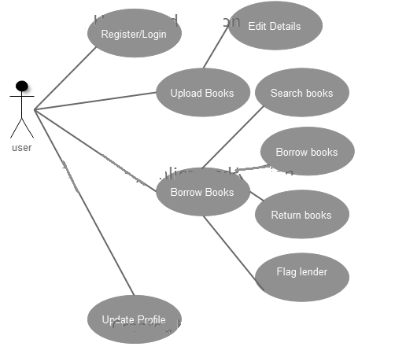

ACTIVITY DIAGRAM:

Login activity:

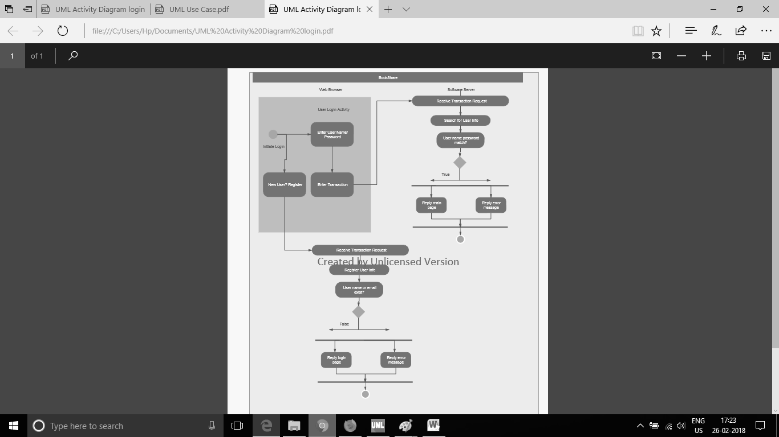

Logout activity:

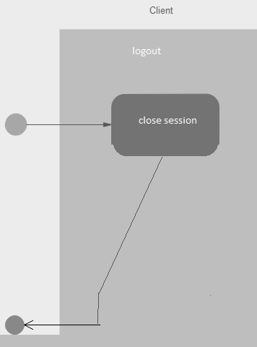

Share book activity:

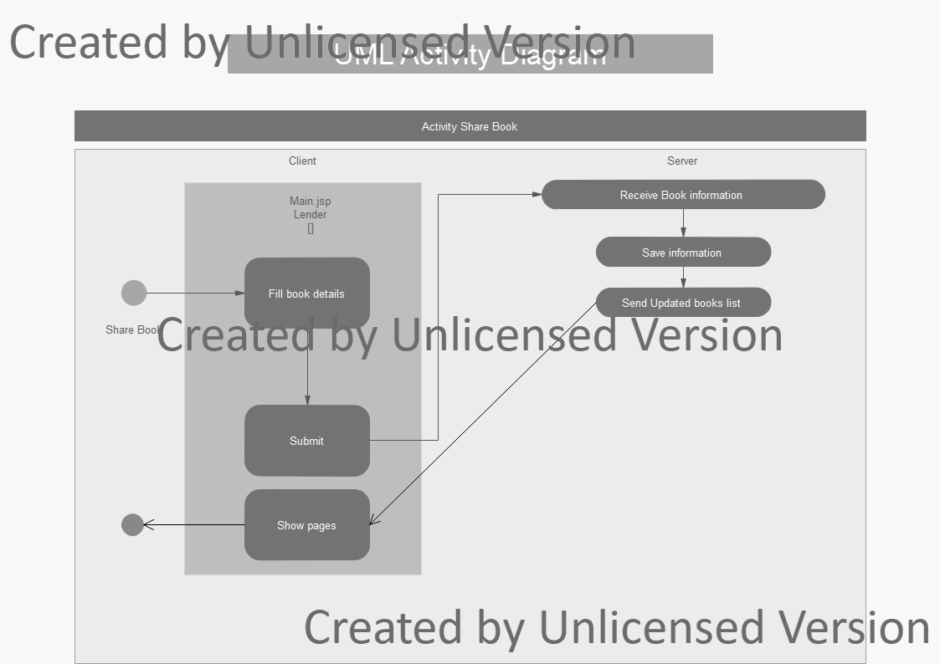

Borrow book activity:

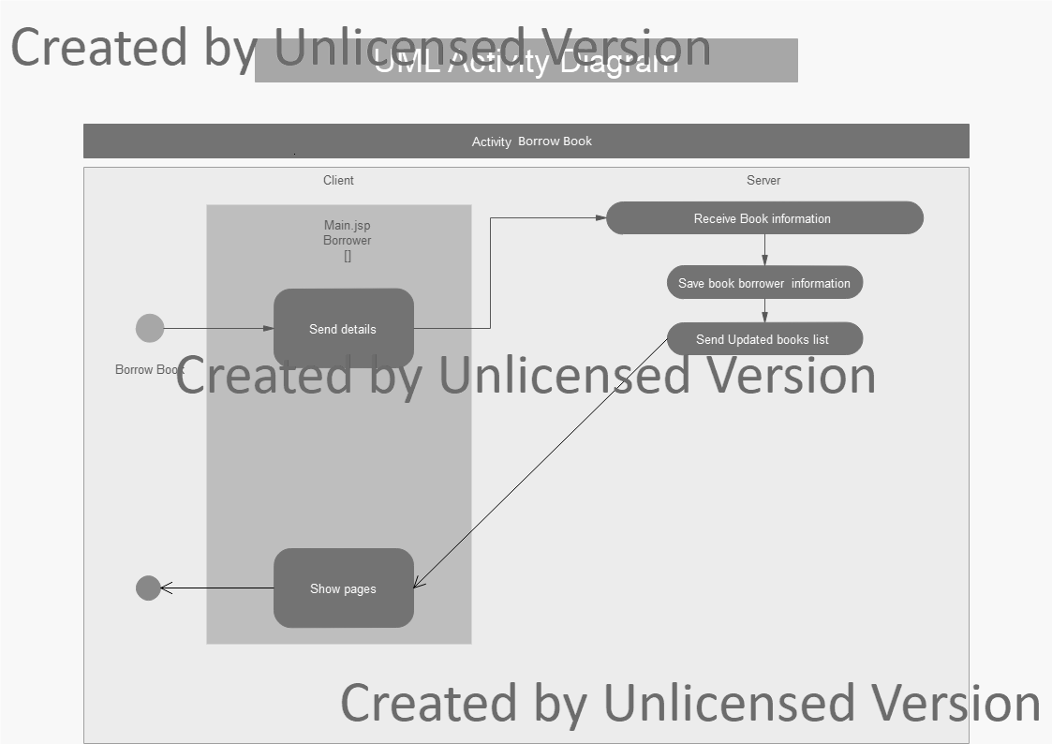

Return book activity:

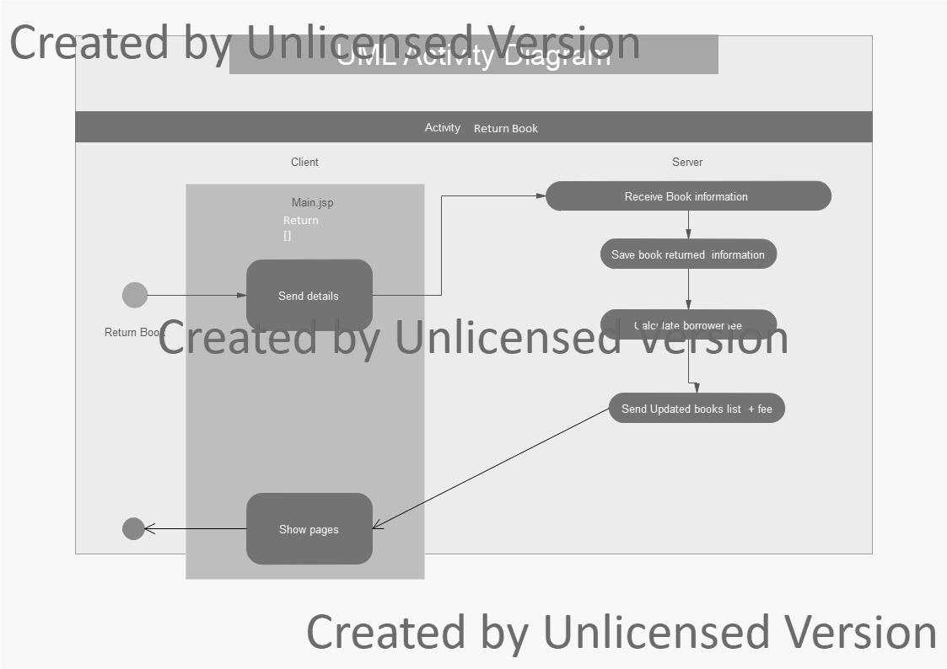

SEQUENCE DIAGRAM:

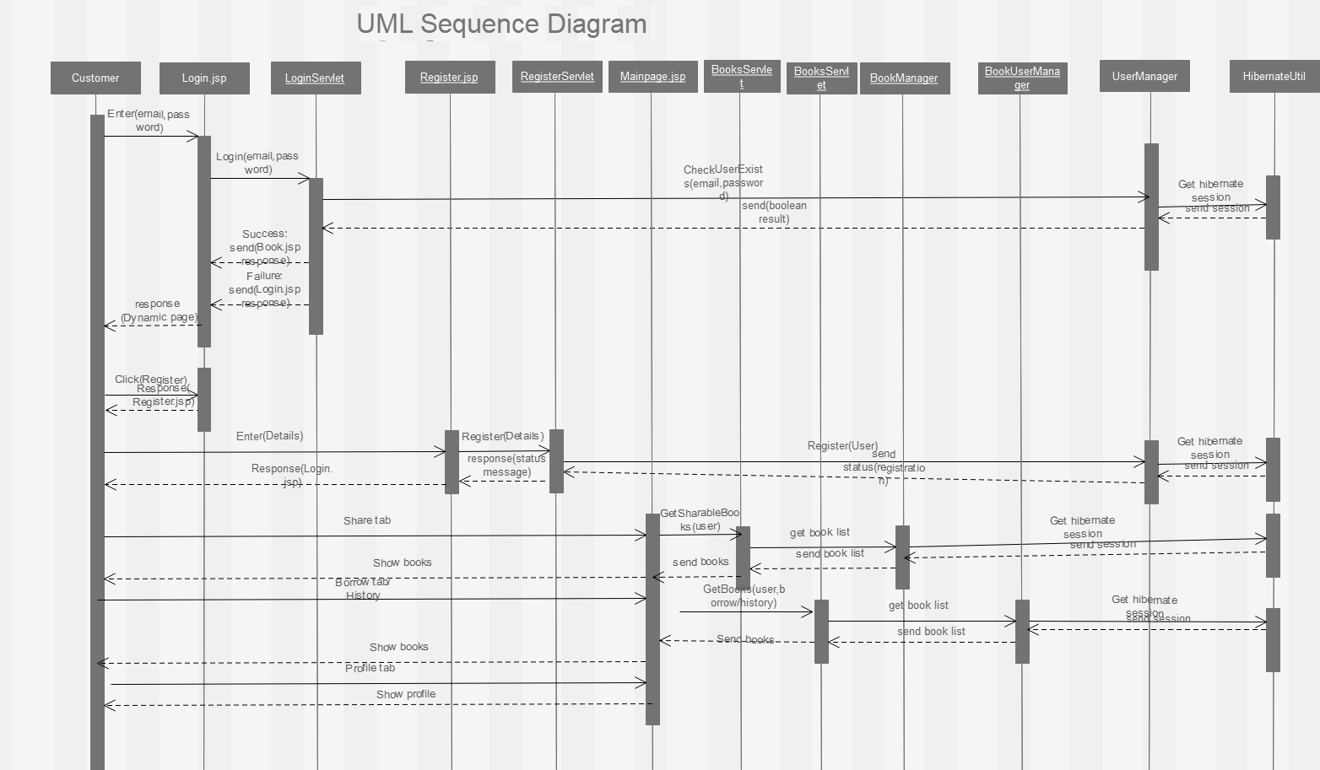

CLASS DIAGRAM:

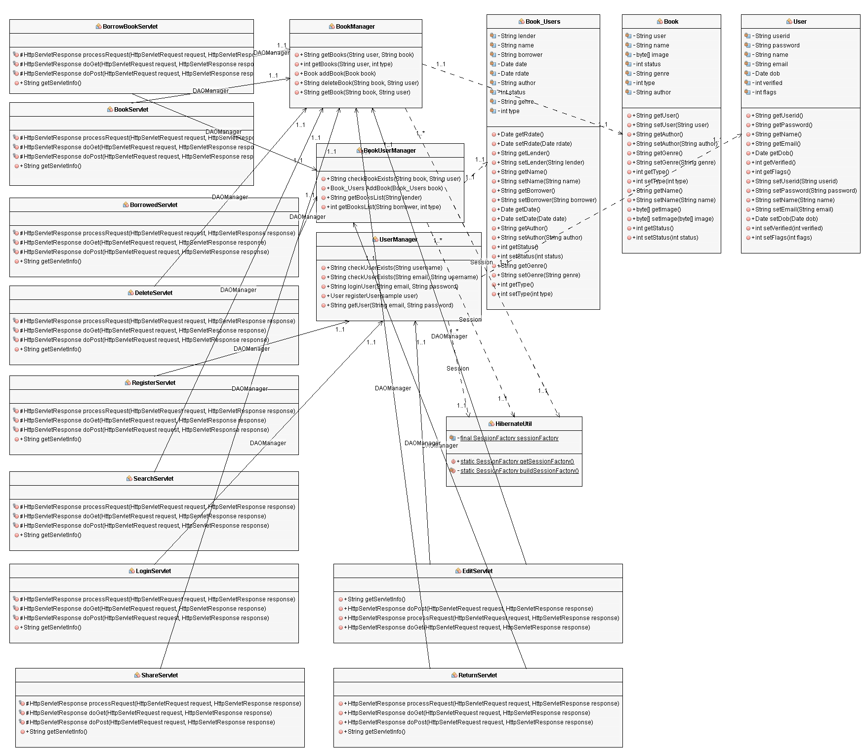

MVC DESIGN LAYOUT W.R.T PROJECT

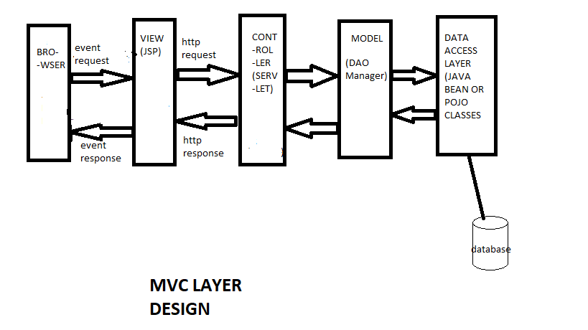

Navigation diagram:

